Transforming Student Services:
Inclusive, Scalable, and Personalised Solutions
Editors
Natalie Oostergo, University of Southern Queensland
Caroline Rueckert, Griffith University
Laura Burge, Swick Learning & Monash University
Priyanka Choudhury, Kangan Institute
Fiona Navin, Edith Cowan University
Contributors
Sara Ardern, Eshan Arya, Kylie Austin, Danay Baker-Andresen, Michelle Baldwin, Kathleen Balson, Elizabeth Beresford, Keri Billingham, Fiona Brady, Laura Burge, Karen Cavu, Michelle Charlton, Kylie Corbett, Simone Daniells, Thi Yen Nhi Dao, Loretta Dayman, Robyn Ekberg, Sachini Gamage, Ebe Ganon, Tina Graham, Kim Gray, Aiden Hill, Emma Hudson, Abdifatah Aden Ibrahim, Nathan John Jaquiery, Graeme Karstaedt, Sakshi Kaushal, Ellie Keegan, Catherine Picton, Samuel Pitman, Karla Portch, Kerrie Lucia Richardson, Janine M. Rix, Stephanie Segura, Lukas Starling, Thanh Tai Tran, Andrew Tui, & Abigail Winter

Keywords
Practice informed scholarship; Student success; Wellbeing; Student services.

Introduction
“Voices From the Field” is a new section in JANZSSA that aims to expand the scope of scholarly engagement by providing a dedicated space for diverse, practice-informed contributions from across the student services community. It responds to a growing recognition that the insights and experiences of those working directly to support student success, whether in professional, academic, or third space roles, are underrepresented in traditional academic publishing. Inspired by the inclusive approach of Professor Alison Cook-Sather in the International Journal for Students as Partners, “Voices From the Field” seeks to create a more accessible and practice-oriented space for reflection, dialogue, and knowledge sharing (Cook-Sather et al., 2021). By promoting equity in scholarly communication and recognising the contributions of all those involved in enhancing student engagement, wellbeing, and belonging, it is possible to cultivate a dynamic and inclusive scholarly community. Such a community more accurately reflects the richness and complexity of student services work across Australia and New Zealand, values practice-informed knowledge, embraces diverse voices, and fosters reciprocal learning across roles and institutions.
Contributors to “Voices From the Field” represent a broad and diverse spectrum of the Australian and New Zealand student services community, encompassing professional staff, academic staff, students, third space practitioners, external partners, first-time authors, emerging practitioners, and those with lived experience. In the spirit of fostering equity and inclusion, contributors were invited to identify aspects of their identities they wished to foreground; those self-described dimensions are shared below in their own words. As such, the views expressed in “Voices From the Field” are those of the individual contributors and do not necessarily represent the official positions of their affiliated institutions. This initiative is grounded in the belief that all individuals engaged in supporting student success, whether through direct service, collaboration, or innovation, possess valuable insights that merit scholarly recognition. By intentionally creating space for short, reflective, and practice-informed submissions, “Voices From the Field” amplifies perspectives that are often underrepresented in or absent from traditional academic discourse.
For this inaugural “Voices From the Field” article, contributors were invited to respond to the question: In a rapidly evolving tertiary education landscape, how do we ensure our services are adaptable, scalable, and personalised to meet the needs of an increasingly diverse student cohort? This prompt reflects the evolving policy landscape driven by the Australian Universities Accord which aims to increase the number of people from underrepresented backgrounds succeeding at university. Significant changes in the tertiary environment already impacting student services include the National Higher Education Code to Prevent and Respond to Gender-based Violence, Fee-Free Uni Ready (FFUR), the establishment of the National Student Ombudsman, the Commonwealth Prac Payment, and the interim Australian Tertiary Education Commission (ATEC) and in Aotearoa New Zealand, The Education (Pastoral Care of Tertiary and International Learners) Code of Practice 2021 (NZ) and compulsory Disability Action Plans. Several funding reforms scheduled include demand-driven Needs-based Funding, Managed Growth Funding, and accompanying mission-based compacts, which are designed to underscore a commitment to expanding access and participation for equity students. While these changes are designed with the intention of supporting students through financial relief, advocacy, and access, they will inevitably impact reporting obligations and coordination requirements for student services. While the Australian sector waits for clarity on how the funding will work in practice and how the impact will be evaluated, one thing is clear: institutions will have to prepare for an increasingly diverse student cohort. Student services practitioners will have to grapple with the complex challenge of responding to cohort-specific needs at scale with finite resources. This context demands not only innovation but also a strategic rethinking of how services are designed, delivered, and sustained.
In response to this prompt, the contributions to “Voices From the Field” capture a rich diversity of perspectives, many of which could have been situated in multiple thematic areas. To reflect and encourage this multiplicity, submissions were grouped into five overlapping categories: person-centred approaches, holistic student support, universal design, collaboration and partnership, and agency and strength. These themes are deeply interconnected, revealing the complexity of student services practice and the imperative to approach equity work through multi-dimensional, systemic strategies. Central to the contributors’ submissions is the call to frame student support through a person-centred lens by considering the individuals that they serve. Contributors comment on preserving the “humanness” within data and decision-making processes to foster connection, relationality, and trust. A notable sub-theme is the tension between scalability and the provision of personalisation, especially through the use of artificial intelligence (AI). This tension invites critical reflection on how technological solutions can be designed to maintain relational depth and responsiveness.
These person-centred approaches provide the relational foundation for holistic systems of student support, anchoring institutional strategies in empathy, responsiveness, and respect for the individual student experience. Contributors advocate for support models that transcend siloed service delivery by embedding practices that reflect the diverse and evolving needs of students within curriculums and within institutions. Adaptable whole-of-university strategies and flexible service models are identified as essential for integrating support across institutional boundaries, thereby fostering continuity, responsiveness, and inclusivity. To achieve this, contributors emphasise the need to address challenges at the systems level through universal design principles that identify and dismantle institutional barriers to equity and inclusion. By designing for intersectionality through an inclusive cultural lens, the emphasis is placed on embedding equity work throughout systems and processes to ensure meaningful and sustained impact.
This work is dependent on harmonising diverse perspectives. As a result, partnership is framed as not only a structural arrangement but also an inclusive process and ethos that brings more voices into the conversation. Collaboration and partnership recognise and amplify student agency and strength, ensuring that diverse voices and lived experiences inform both the design of support systems and the understanding of student success. This is reflected in a shift away from passive risk management towards proactively understanding and supporting student success. Drawing on the work of scholars such as O’Shea and Delahunty (2018), contributors encourage practitioners to move beyond deficit narratives and instead adopt strength-based approaches that foreground student agency and strengths. For many students, particularly those from marginalised communities, mattering is found not in assimilation but in being seen, being valued, and in having the ability to carve out space within institutions (Cook-Sather et al., 2023). This extends to practitioners, whose authenticity and relational presence serve not only as sources of expertise but position them as co-creators of inclusive environments and powerful role models of courage and visibility.
These contributions offer a transformative vision for student services that is grounded in humanity, equity, and shared responsibility and are responsive to the challenges and opportunities of a rapidly changing tertiary landscape. The fluidity of the themes reflects the interconnected nature of the issues explored and invites the reader to consider the diversity of perspectives that unfold through the juxtaposition of the contributors’ voices.

Person-centred approaches
Diversity is at the heart of our work at Charles Darwin University. With an increasingly diverse cohort, do we look to AI for scalability of support? It is instantaneous and is available 24/7. It can have different voices and, one day, it may even be able to pick up on tone of voice and body language. However, by incorporating AI, we could lose our connections with students and our ability to recognise, respond, and diversify our approaches. Human connection, empathy, and belonging are important to our students and recognised as key factors in motivation and academic performance. It is not groundbreaking to state that we need a whole-of-institution response, but we can only scale effectively by everyone playing a part. As third spacers, our growing legitimacy and credibility enable us to influence, collaborate, and form partnerships to create our aspiration of a university where everyone belongs.
— First Year Student Success Team, living and working on Larrakia Country with students commencing at Charles Darwin University
It would be easy to craft a technology-based reply. But for all of its many benefits, technology also brings a divide. Learners become isolated and lonely amidst digitally mediated “social” interactions. People are overwhelmed by the constant onslaught of information, and the impetus to untangle fact from not. Educators feel pressure due to the immediacy of communications and expectations for prompt responses and attention. Instead, to ensure genuine, responsive services, I would argue we need to maintain the “person” in personalised. Embrace our humanness, and the empathy and insight that comes with that. Only our unique capabilities as humans offer us the insight to respond to others in kind, not as a number or data analytic. From our personalisation, our service offerings will be driven by demand. Yes, we can leverage technology to drive scalability, but our true strength will be to offer understanding and human connection: exactly what people want.
— Michelle Charlton, driving professional development for VET educators through Skills Education

I’ve been a disability practitioner in higher education for six months but have an extensive background in disability both personally and professionally. So much tension exists in the disability space: a constant tug-of-war between support needs and available resources, privacy and “appropriate” disclosure, and the expectations of the non-disabled community versus capacity and legislation. In amongst the noise, there is one truth: when people are respected, included, and heard, positive outcomes follow. Creating scalable systems that keep the individual at the heart of the processes is not easy, but combining structured systems like the Disability Discrimination Act 1992 (Cth) and Disability Standards for Education 2005 (Cth) with best practices, the individual as expert, and practitioner expertise is the best way to ensure consistency, equity, and meaningful outcomes. It will never be a simple process and will always require practitioner discretion, but at the end of the day, you need the human touch to keep humans at the forefront.
— Emma Hudson (she/her), National Learning Support Coordinator at JMC Academy
Artificial intelligence is creating data-driven information systems to generate specific timely data that identifies students in most need of support. Paradoxically, students in most need of support are least likely to access support (Lizzio & Wilson, 2013). By identifying and outreaching early to students through nudging via email, text, or a phone call, we provide timely policy advice and can assist students to connect to support services based on their individual circumstances. My experience of speaking with students using solution-focused coaching language helps students connect with support services, thus building the skills they need to succeed and achieve their dreams (see Figure 1).
Figure 1
Using AI to Nudge Students and Improve Outcomes
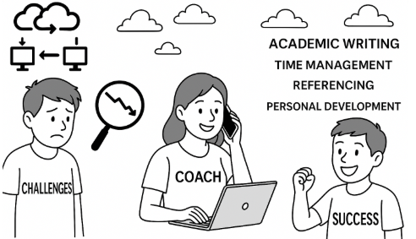
Note. Image generated using ChatGPT Version 4.0, 2025 (https://chatgpt.com/).
— Michelle Baldwin, student & professional staff, BBA, BSC, Student Success Advising, University of Southern Queensland

Holistic student support
Our collaborative approach ensures our services are integrated, not isolated. Guided by our annual operational team plan, we focus on key student cohorts, prioritising target groups and addressing the unique needs of faculties, clubs, and associations. Informed by student feedback, industry insights, and work trends, we emphasise a one-to-many model to reach more students. We partner with stakeholders to tailor career messaging and leverage their connections to attract students, rather than relying solely on our promotion. Additionally, personalised one-to-one support is available both in person and online. Students trust our services when they see us actively engaged in their spaces and when key staff advocate for our value.
— Andrew Tui, Careers and Employment team (Te Ratonga Rapu Mahi), Manager Careers and Employment, Victoria University of Wellington
It is exciting to be welcoming an increasingly diverse student cohort, but we must respond at multiple levels: (1) preface the university journey with resources and services that help students define their personal values and ensure alignment with their chosen program and future profession; (2) ensure aspiring students can see profiles of successful students that “look like them” to allay any fears that they may not belong; (3) identify and remove institutional barriers that preclude confidence and success; (4) acknowledge the reality of the rising cost of living and the impact on the student experience; and (5) give students agency and provide support that is in an individual student’s best interests at a given point in time, supporting students to transition in, and transition out, of tertiary studies, as required. It will be essential to intentionally break down power imbalances and engage in authentic person–person connection.
— Dr Janine Rix, Student Experience Coordinator, Faculty of Health, Medicine and Behavioural Sciences, The University of Queensland, Australia
I believe ensuring adaptability, scalability, and personalisation hinges on deep, continuous relevance. We must actively monitor market trends and immerse ourselves in the nuanced language of student cohorts, understanding everything from evolving communication styles to the true meaning behind emojis. While experience offers thematic insights, constant grassroots engagement is crucial to grasp emerging issues. It is vital to avoid clubbing diverse experiences; for instance, “women's issues” are not monolithic. We must understand intersectionality. Our focus must shift from what we currently offer to what students truly need, avoiding market myopia in student services and amenity provision. This responsive, student-centric approach is key to meeting the demands of our increasingly diverse population.
— Dr Eshan Arya, the Dean of Students and Deputy Head at International House, University of Melbourne
Student services stories are predominantly about undergraduate coursework, but we work with research students at one Australian university. We are third space educators, who help research students to navigate the hidden curriculum of writing and employability. Karen and Keri work in the central research division; Abbe works in a faculty. Research students experience their support in ad hoc, often happenstantial ways. This year, we are trialling a new holistic service—the Researcher Feedback Hub. This initiative draws together our support skills to embed careers learning into the safe and established space of academic writing support. Students can attend a fortnightly one-hour drop-in session and practise giving and receiving feedback on their writing with peers and expert communicators—whether on a thesis or article, grant, or job application. The first Feedback Hub ran on 4 April 2025, and we will write future articles detailing and evaluating our initiative.
— Karen Cavu, HDR Career Educator, Graduate Research Education & Development, QUT; Dr Keri Billingham, Senior Lecturer & HDR Language & Learning Educator, Graduate Research Education & Development, QUT; Dr Abigail Winter, Academic Writing Coach, Faculty of Creative Industries, Education and Social Justice, QUT
To meet the needs of an increasingly diverse student cohort, we need to explore new ways to exchange ideas, experiences, and reflections between students and success advisors. Drawing inspiration from the gamification approach (Dichev & Dicheva, 2017), I designed a game to facilitate these conversations at the University of Southern Queensland welcome week. Casting out invites students to win prizes by catching a paper fish and answering a question, in conversation with success advisors. The questions encourage students to share what study looks like for them. Critically, this also opens a space for students to ask the success advisor questions about their own experience, facilitating shared learning and understanding between the advisor and the student. Continuing to share these conversations every trimester takes us out of the advisor seat and puts us into the student’s seat, allowing us to learn about the diverse needs of our cohort, whilst facilitating unique reflections and introspections with each student.
— Kerrie Richardson (she, her), living on the lands of the Turrbal peoples in Magandjin Meanjin Brisbane, Senior Student Success Advisor at the University of Southern Queensland

Universal design
For new students at Edith Cowan University, we’ve developed an onboarding framework (see Figure 2) that draws on Whadjuk Noongar Life Layer knowledge, student co-design, Lizzio’s (2006) Five Senses of Success, and Maslow’s (1943) Hierarchy of Needs. This layered approach supports diverse student transitions by personalising support based on individual experiences and needs, not only demographic data. Built with dynamic program logic, this framework enables activities to be responsive to change and opportunity while staying anchored in outcomes, with student involvement and whole-university collaboration through a universal design approach. By focusing on outcome measurement over output measurement, we can ensure evolving services remain relevant, inclusive, and impactful.
Figure 2
Re-Imagining Orientation
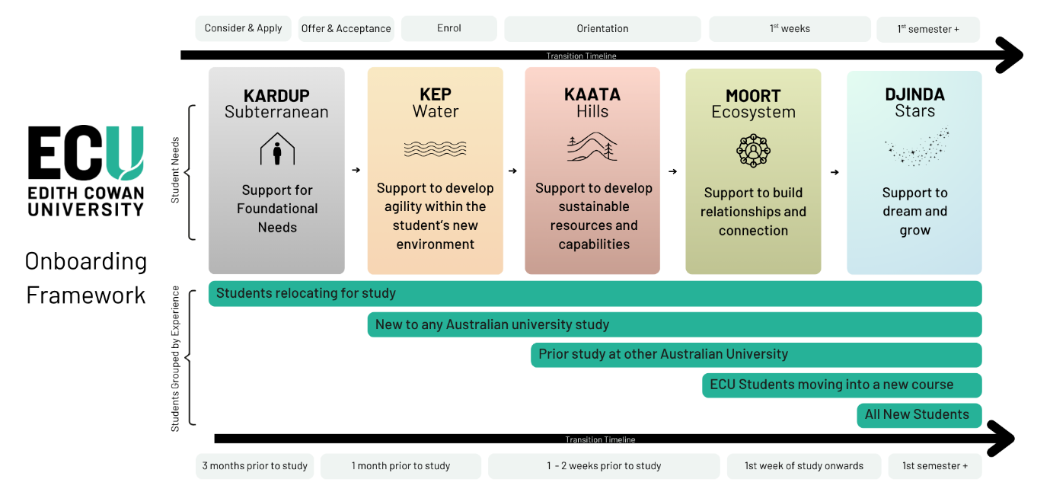
— Kathleen Balson, Elizabeth Beresford, Kylie Corbett, Loretta Dayman, Robyn Ekberg, Kim Gray, Aiden Hill & Kylie Austin. Project Team, Edith Cowan University

Inclusion, respect, and belonging must be the cornerstones of how we adapt. We can’t serve or engage an increasingly diverse student cohort with static systems or performative gestures. We need to actively listen, co-design with students, particularly those historically underrepresented, and embed equity into every layer of service delivery. Personalisation isn’t just about tech; it’s about cultural responsiveness and understanding the lived experience behind the data. Scalability comes from embedding inclusive practices into our core frameworks so they’re not add-ons, but business as usual. I’ve seen the impact when respect is made visible in everyday interactions. It builds trust, community, and sustained engagement. Most importantly, adaptability starts with people, not just process.
— Laura Burge, Educational Leader
At the University of the Sunshine Coast, our student services teams ensure that our services are adaptable, scalable, and personalised by embedding our expertise where it reaches all students—in the curriculum. Recognising the socio-cultural incongruity many students experience (Devlin, 2013), we partner with academic staff to ensure that the skills underpinning success are explicitly taught. We support academic staff by providing customisable Canvas pages on academic, wellbeing, and career development topics, which can be easily tailored for teaching. Our consultations with academic staff yield a deeper mutual understanding of the strategies that promote student success. By coordinating the delivery of the resources at a program level, we avoid overburdening the existing curriculum while ensuring students develop the breadth of skills required. This approach reaches thousands of students each semester, including many who may not engage with centralised services, and has created a network of champions that extends our teams’ impact in a sustainable way.
— Drs Danay Baker-Andresen and Catherine Picton, Student Success and Development Team, Student Services, University of the Sunshine Coast
As a neurodivergent researcher and practitioner who spent several years studying and working in higher education equity roles, I’ve seen how, despite good intent, our student support systems continue to fail neurodivergent students. Universities see “reasonable adjustments” as the silver bullet for the academic barriers disabled students face, but we’re falling down when it comes to services. The question shouldn’t be how we accommodate difference case-by-case, but why our default systems assume neurotypical brains and non-disabled bodyminds in the first place. True adaptability means designing universal services that work for neurodivergent students without requiring constant disclosure, advocacy battles, or endless paperwork. This looks like predictable processes with clear timelines, sensory-considerate environments by default, and clear communication with different engagement options across the service ecosystem. When neurodivergent students can access what they need without jumping through hoops, everyone benefits: we all save time, energy, and emotional labour, and our students succeed.
— Ebe Ganon, PhD Candidate at UNSW Canberra, Research Associate at the University of Tasmania, Australia, and Community Engagement and Inclusion Practitioner
Technology is increasingly prevalent in our tertiary education landscape. While this offers opportunities for adaptable, scalable, and personalised teaching practices, it can also present barriers if not done well. Many tertiary educators have not received explicit training in why or how they can develop online learning materials in a way that maximises accessibility for students. I developed this infographic (see Figure 3) to open a conversation with my colleagues about why accessibility is important, our obligations as educators, and to offer practical tips for ensuring our learning materials better meet the needs of an increasingly diverse student cohort.
Figure 3
Accessibility: Tips for Educators
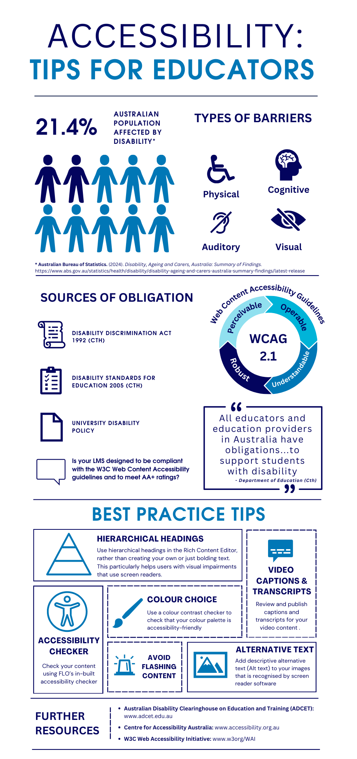
— Simone Daniells, Lecturer and Student Success Lead in Law, College of Business, Government and Law, Flinders University
The Education (Pastoral Care of Tertiary and International Learners) Code of Practice 2021 (NZ), which came into force in January 2022, emphasises the responsibility of educational providers to ensure that learners’ wellbeing and needs are: upheld; responsive to wellbeing in policy, practice, and procedural systems; honouring Te Tiriti o Waitangi; accessible across operating environments; supportive; inclusive; and safe in accommodation situations (and more). For care experienced young people to achieve a tertiary education qualification is challenging as only 14% of this cohort gain a tertiary qualification by age 25, in comparison to 50% of the general population (Matheson, 2023, p. 13). Tertiary institutions must lean on the Pastoral Code to improve tertiary pathways and break down barriers for care experienced young people. Consistency across the tertiary education sector is needed to ensure that support systems, scholarships, financial support, consideration of diversity, and inclusive practices exist to empower vulnerable students to pursue higher educational achievement. Barriers need to end and best practice to prevail within tertiary institutions in Aotearoa New Zealand to improve the above statistic.
— Nathan Jaquiery, Senior Student Care Advisor, Student Care Team and PHD candidate, University of Canterbury, New Zealand

Collaboration and partnership
Working over the last 18 months to develop and integrate our Student Voice and Partnerships Framework (Griffith University, n.d.) has been both a career highlight and a reality check. We set out to articulate partnership as a core value, but culture alone didn’t embed change. The research provided strong foundations (Cook-Sather et al., 2018; Healey et al., 2014), but we also needed a deeper shift in how we designed and delivered with students. This came when we stopped asking how to define it and started asking how to design for it. If we utilise principles of human-centred design (Brown & Katz, 2009), empathising is a powerful starting point, but it must lead to accessible structures and action. In a time of rapid sectoral change, Students as Partners approaches aren’t just a nice-to-have, they can build better services and help futureproof what comes next. The value lies not just in what students contribute, but in how we design our services to ensure they can.
— Sara Ardern, living on the lands of the Kombumerri peoples, part of the Yugambeh language region, Practice Lead - Student Partnerships at Griffith University
Research has demonstrated that psychological distress among university students is growing (Baik et al., 2019). The question we must ask is: Are we truly equipping our student partners who provide frontline support to handle this reality? Do they have clear protocols, guidance, and robust professional development to navigate students in distress and serious disclosures effectively? Do they fully understand their institutional obligations? Are they empowered to act, escalating concerns appropriately, ensuring students receive the right support? This is not just a matter of individual preparedness. Managers need a holistic view of serious incidents and disclosures, otherwise how can institutions ensure consistency, oversight, and accountability in supporting students at risk? Ultimately, we must match our investment in professional development to the level of responsibility and risk exposure we assign to student partners. Universities cannot afford to assume these roles are supplementary—student partner support sits at the very heart of student wellbeing.
— Tina Graham, Manager Student Success and Retention, Queensland University of Technology; Samuel Pitman, Senior Educator (Retention), Queensland University of Technology; Lukas Starling, Educator (Retention), Queensland University of Technology
In my dual roles as a Muslim Wellbeing Advisor and an International Student Advisor at the University of Canterbury, my approach centres on proactive, culturally responsive care to meet the needs of an increasingly diverse student population. The foundation of my practice is shaped by lived experience—from advocating for inclusive space design in infrastructure to developing mental health referral pathways for Muslim students. Scalability is achieved through developing and maintaining partnerships with internal services and community organisations. For us, scalability doesn’t mean standardisation. Systems must flex with complexity and allow services to remain both strategic and responsive. We also leverage digital platforms to share timely, relevant resources and reach large student audiences throughout the academic year. Personalisation comes through ongoing engagement and being a trusted, visible presence in student spaces that often feel overlooked. In short, services must meet students where they are—not the other way around.
— Abdifatah Ibrahim (he/him), Muslim Wellbeing and International Student Advisor, University of Canterbury, New Zealand. Abdifatah supports diverse student populations through culturally responsive mental health, wellbeing, and community-based initiatives grounded in equity, belonging, and care

Agency and strength
It is undoubtedly a challenging time for students, both domestic and international. Whether it is ongoing geopolitical conflicts globally or rising inflation locally, students are currently facing a diverse range of hardships. As a student counsellor, I find myself eagerly searching for tools in my clinical practice to provide support. However, as is sometimes the case in counselling, I ultimately realised that the answer had been in front of me all along. I came to this realisation when I asked multiple students what kept them going and got a resounding response: “it’s my passion for this course”. This simple reflection from students is truly a testament to their resilience and commitment to their passion. The passion they take to their ongoing journeys. And while we as counsellors may only be a part of their journey briefly, I found that bringing their resilience to the forefront can make all the difference.
— Sakshi Kaushal, Counsellor at Holmesglen Institute of TAFE and research fellow at University of Melbourne
As a late-diagnosed neurodivergent educator, the most powerful tool I can use to create personalised and adaptable student support services is authenticity. While part of me cringes at using that buzzword, time and again it is being honest and open about my own disabilities that most empowers the students I work with. In an education system underpinned by single narratives, it is diverse stories that help students feel seen and connected. In her TED Talk, “The Danger of a Single Story”, Adiche (TED, 2009) argues for “how impressionable and vulnerable we are in the face of a story, particularly as children” (1:44). Many students only hear a single story of academic success—the one involving Australian Tertiary Admission Ranks (ATARs) and salaries. By voicing our own stories, we normalise the need for support and the notion that most success is a team effort. We also create space for our students to write their own stories.
— Karla Portch (she/her), Learning Adviser at UQ College, Brisbane, Australia
The nature of almost any chronic condition is that its range and severity of symptoms will fluctuate significantly over time. This presents the difficulty for student services (wellbeing and equity) of accurately documenting the condition and making appropriate accommodations for it. There is the need for student services to develop a more flexible approach to chronic malady, given that standard forms and procedures are often inadequate to handle its protean nature.
— Graeme Karstaedt is a sessional academic in literature and creative arts at Murdoch University
To adapt to community needs, universities must create better Recognition of Prior Learning (RPL) pathways for “tradie” veterans who put tools down to move into professional roles. We know that RPL widens participation, e.g., Trade to Teach; why aren’t there more constructs for other award programs? RPL processes need to respect decades of skill development through trades to support people for the next stage of their working life so Australia can benefit from a second wave of learning to extend labour force participation. This is an opportunity to create social transformation. Do it for the country! See Figure 4.
Figure 4
Do it for the Country!

Note. Image generated using Copilot, 2025 (https://copilot.cloud.microsoft/).
— Fiona Brady, professional staff member at the University of Southern Queensland

Conclusion
“Voices From the Field” reflects a growing recognition that practice-informed knowledge is essential to enriching scholarly discourse. By intentionally creating a space for diverse voices, reciprocal learning, and equity in scholarly communication, “Voices From the Field” cultivates a sense of mattering for practitioner insight. It is practitioners who have a deep understanding of how equity and inequity unfold in systems within institutions and the resources and opportunities that can shape inclusion and turn positive intent into real outcomes. The thematic contributions: person-centred approaches, holistic student support, universal design, collaboration and partnership, and agency and strength, highlight the interconnectedness of student services practice. They underscore the importance of systematising humanness, trust, and relational depth within institutional frameworks to turn meaningful cultural shift into impact.
Holistic design thinking in this context becomes a deeply person-centred process that requires trust, connection, and the creation of systemic frameworks that genuinely listen. Universal design reinforces this by shifting the burden of adaptation from the student to the system, ensuring that equity is embedded at every level of service delivery. At the core of this service design lies capability: the capacity to partner collaboratively, to integrate diverse elements of service design, and to build systems that reflect and respond to the full complexity of students’ lives. These strengths-based frameworks amplify the agency, creativity, and passion that students possess. Together, these themes offer a transformative vision for equity service design at scale that is grounded in humanity, strength, and shared responsibility.

References
Baik, C., Larcombe, W., & Brooker, A. (2019). How universities can enhance student mental wellbeing: The student perspective. Higher Education Research & Development, 38(4). 674–687. https://doi.org/10.1080/07294360.2019.1576596
Brown, T., & Katz, B. (2009). Change by design: How design thinking transforms organisations and inspires innovation. Harper Business.
Cook-Sather, A., Felten, P., Stewart, K. P., & Weston, H. (2023). Reviving the construct of mattering in pursuit of equity and justice in higher education: Illustrations from mentoring and partnership programs. In E. Rueda & C. Lowe-Swift (Eds.), Academic belonging in higher education: Fostering student connection, competence, and confidence (pp. 198–214). Routledge. https://doi.org/10.4324/9781003443735-18
Cook-Sather, A., Matthews, K. E., Ntem, A., & Leathwick, S. (2018). What we talk about when we talk about students as partners. International Journal for Students as Partners, 2(2), 1–9. https://doi.org/10.15173/ijsap.v2i2.3790
Cook-Sather, A., Slates, S., Acai, A., Baxter, J., Bond, R., Lowe, T., Zurcher, H., O’Brien, J., Tavares, V., Lewe, M.-T., Khan, A., Poole, H., Smith, A. C., Iqbal, M. Z., Arm, K., Escobar Lema, J. E., Groening, J., Garg, K., Bello Rinaudo, N. L., … Lewis, R. (2021). Diversifying students-as-partners participants and practices. International Journal for Students as Partners, 5(1), 146–159. https://doi.org/10.15173/ijsap.v5i1.4627
Devlin, M. (2013). Bridging socio-cultural incongruity: Conceptualising the success of students from low socio-economic status backgrounds in Australian higher education. Studies in Higher Education, 38(6), 939–949. https://doi.org/10.1080/03075079.2011.613991
Dichev, C., & Dicheva, D. (2017). Gamifying education: What is known, what is believed and what remains uncertain: A critical review. International Journal of Educational Technology in Higher Education, 14(9). https://doi.org/10.1186/s41239-017-0042-5
Disability Discrimination Act 1992 (Cth).
Disability Standards for Education 2005 (Cth).
The Education (Pastoral Care of Tertiary and International Learners) Code of Practice 2021 (NZ).
Griffith University. (n.d.). Student voice and partnerships framework. https://www.griffith.edu.au/students/partnerships#Framework
Healey, M., Flint, A., & Harrington, K. (2014). Engagement through partnership: Students as partners in learning and teaching in higher education. Higher Education Academy. https://www.advance-he.ac.uk/knowledge-hub/engagement-through-partnership-students-partners-learning-and-teaching-higher
Lizzio, A. (2006). Designing an orientation and transition strategy for commencing students: Applying the five senses model. Griffith University. https://studylib.net/doc/5862488/designing-an-orientation-and-transition-strategy-for
Lizzio, A., & Wilson, K. (2013). Early intervention to support the academic recovery of first-year students at risk of non-continuation. Innovations in Education and Teaching International, 50(2), 109–120. https://doi.org/10.1080/14703297.2012.760867
Maslow, A. H. (1943). A theory of human motivation. Psychological Review, 50(4), 370–396. https://doi.org/10.1037/h0054346
Matheson, I. (2023). A guide for tertiary education organisations on supporting care experienced learners. Tertiary Education Commission. https://www.tec.govt.nz/assets/Forms-templates-and-guides/Guide-for-Tertiary-Education-Organisations-on-supporting-care-experienced-learners.pdf
O’Shea, S., & Delahunty, J. (2018). Getting through the day and still having a smile on my face! How do students define success in the university learning environment? Higher Education Research & Development, 37(5), 1062–1075. https://doi.org/10.1080/07294360.2018.1463973
TED. (2009, October 8). Chimamanda Ngozi Adichie: The danger of a single story. [Video]. YouTube. https://www.youtube.com/watch?v=D9Ihs241zeg

The authors may be contacted via:
JANZSSA — janzssa@anzssa.com
Please cite this paper as:
Oostergo, N., Rueckert, C., Burge, L., Choudhury, P., Navin, F. Ardern, S., Arya, E., Austin, K., Baker-Andresen, D., Baldwin, M., Balson, K., Beresford, E., Billingham, K., Brady, F., Cavu, K., Charlton, M., Corbett, K., Daniells, S., Dao, T. Y. N., … Winter, A. (2025). Voices from the field: Transforming student services: Inclusive, scalable, and personalised solutions. Journal of the Australian and New Zealand Student Services Association, 33(2), 133–146. https://doi.org/10.30688/janzssa.2025-2-06



This work is licensed under the Creative Commons Attribution 4.0 International License. To view a copy of this license, visit http://creativecommons.org/licenses/by/4.0/ or send a letter to Creative Commons, PO Box 1866, Mountain View, CA 94042, USA.

