Beyond Information Sessions:
Transforming the International Student Welcome Experience
Alessandro Sereni
The University of Adelaide

Abstract
The international student welcome is a cornerstone of university orientation programs. It plays a critical role in helping international students transition to their new academic and social environment. For Semester 1, 2025, the International Student Support team at the University of Adelaide reimagined this experience, drawing on flipped learning pedagogy, outdoor orientation programs (OOPs), and brand experience principles. Traditional, information-heavy sessions were replaced with interactive, community-building activities, supported by pre-arrival digital resources. This redesign aimed to foster a sense of belonging and enhance student engagement while ensuring compliance with the Education Services for Overseas Students (ESOS) framework. This paper reviews the relevant literature underpinning the approach and outlines the development and delivery of the redesigned welcome program. Drawing on post-event student and staff feedback, it highlights both strengths and areas for improvement. The insights are shared with the aim of informing and inspiring practitioners working to enhance international student transition programs across the Australian higher education sector and beyond.

Keywords
International student support; Specialist support; Higher education; Student experience; Student engagement; Orientation.

Introduction: Beyond orientation week information sessions
Typically held during orientation week (O’Week) before semester or trimester classes begin, the international student welcome (ISW) is a cornerstone of university orientation programs. This event provides structured activities designed to help international students adapt to both university life and the broader Australian cultural context. As their first major interaction with the campus community, the ISW significantly shapes international students’ initial impressions and plays a crucial role in their overall satisfaction, long-term retention, and future engagement with campus activities (Glass & Westmont, 2014; Mayhew et al., 2010; Moodie, 2016; Sum et al., 2010). Recognising its importance, universities across Australia strive to create welcoming experiences that not only foster a sense of belonging but also meet the compliance requirements outlined in the National Code of Practice for Providers of Education and Training to Overseas Students (Department of Education, 2018).
However, despite the best intentions, ISWs often rely on passive learning methods. These typically include extended presentations in lecture theatres and halls that often lead to information overload (Zimmer, 2021; Smyth & Lodge, 2012). Although some interactive elements, such as Kahoot or Mentimeter quizzes, are sometimes included, the format remains predominantly lecture-based or panel-style. This one-directional approach can overwhelm students, reducing their engagement and limiting the event's effectiveness (Edward, 2003; Kift, 2009; McPhail et al., 2015). Additionally, the lesser emphasis on structured community-building activities embedded within ISWs can create barriers for international students attempting to form meaningful connections with peers and staff (Glass et al., 2015; Hendrickson et al., 2011). Based on the author's experience as both a former international student in Australia and a professional staff member involved in orientation and ISW planning and implementation, international students highly value O’Week campus events. However, many tend to attend these activities either alone or alongside peers from their home country. Without deliberately designed opportunities for meaningful interaction, many international students struggle to expand their social networks during this critical introduction to university life. This may limit the diversity of their social networks and campus connections throughout their academic journey.
The International Student Support (ISS) team at the University of Adelaide has long recognised these challenges but lacked the right combination of drivers to conduct and test a comprehensive redesign of its ISW blueprint until recently. By the end of 2024, three factors converged to create new momentum for change. First, the University of Adelaide Division of Academic and Student Engagement (DASE), of which ISS is part, renewed its strategic focus on enhancing students' sense of belonging through innovative campus-based experiences. Second, positive student feedback from the Semester 2, 2024 ISW—describing it as enriching, socially engaging, and informative—reinforced the value of continuing to improve these experiences. Third, the merger between the University of Adelaide and the University of South Australia presented an opportunity to pilot an enhanced ISW model that could potentially influence future orientation programming at the new Adelaide University in 2026. This confluence of institutional priorities, student feedback, and organisational transition created the ideal context and conditions for reimagining the ISW experience.
Accordingly, for Semester 1, 2025, the ISS team revamped its ISW by incorporating elements from flipped learning, outdoor orientation programs (OOPs), and brand experience design. This new approach directly addressed the challenges identified above. The flipped learning elements helped reduce information overload by providing digital resources before arrival, allowing face-to-face time to focus on engagement rather than passive listening. The OOP components created structured opportunities for meaningful peer connections, directly addressing the community-building barriers. Grounded in brand experience design principles, ISW activities engaged students across behavioural, emotive, intellectual, and sensory dimensions.
This paper examines the guiding principles, development process, and implementation of this new iteration of the ISW at the University of Adelaide. It also discusses its strengths and weaknesses based on the post-event feedback gathered from students and staff to evaluate its impact. By sharing these learnings, this paper aims to inform best practices in international student orientation and provide evidence-based insights for higher education professionals working to improve international student transition programs across the Australian higher education sector and beyond.

The theoretical framework: Flipping the International Student Welcome
The redesign of the ISW draws upon three complementary frameworks: flipped learning from education, OOPs from experiential learning, and brand experience from marketing. While these approaches come from different fields, they all share one key idea: creating transformative experiences that actively engage participants rather than positioning them as passive recipients of information. Together, they provide a comprehensive foundation for an ISW theoretical framework that prioritises meaningful interaction over conventional content delivery.
Flipped learning is a pedagogical approach that reverses the traditional order of instruction by delivering content outside of class and using in-person time for active learning. First formalised by Bergmann and Sams (2012), this approach has gained traction in higher education for its efficient use of limited contact hours. Research by O'Flaherty and Phillips (2015) demonstrates that successful flipped learning involves providing content before class, allowing in-person sessions to focus on critical thinking, creativity, and collaboration, ultimately enhancing student satisfaction and retention. Abeysekera and Dawson (2015) highlight additional benefits, such as reduced cognitive load, self-paced learning opportunities, and enhanced personalisation. The ISS team at the University of Adelaide applied flipped learning in redesigning the ISW to address the information overload challenge. By providing key information digitally before students arrived, the team enabled self-paced learning while strategically reserving in-person time for community-building activities inspired by OOPs.
OOPs are a well-established approach to university transition, using outdoor experiences and structured small group activities to help students adjust to university life (Bell et al., 2010). By placing students in new situations with shared challenges, OOPs facilitate the rapid development of peer networks, which serve as crucial support systems throughout university life (Wolfe & Kay, 2011). Research also suggests that OOPs can enhance students' sense of belonging and confidence in navigating academic and social expectations (Ribbe et al., 2016). Even brief campus-based outdoor activities, when designed with community-building elements, can significantly enhance social connections and institutional attachment (Andre et al., 2017). Drawing on these findings, the ISS team included structured problem-solving tasks, shared experiences, and guided interactions in ISW campus tours and other activities, with the aim of fostering meaningful connection while simultaneously developing a distinctive brand experience.
Brand experience refers to the way individuals perceive and respond to interactions with a brand across multiple dimensions: sensory (how something looks, sounds, or feels), affective (the emotions it evokes), cognitive (the thoughts or associations it triggers), and behavioural (the actions it encourages) (Brakus et al., 2009). Originally a marketing framework, Altschwager et al. (2018) demonstrate its relevance to higher education, particularly in orientation programs, where universities craft experiences that shape student engagement and long-term affiliation. They argue that successful orientation events must integrate intellectual, sensory, affective, and behavioural components to create meaningful social brand engagement. By incorporating these elements, universities can design experiences that not only provide information but also foster a deeper sense of connection, identity, and belonging among students (Altschwager et al., 2018). The ISS team deliberately designed the ISW to engage all four of these dimensions in order to make it more attractive and memorable.
These three approaches complement each other in the ISW redesign: flipped learning creates space for meaningful interaction by providing information beforehand; OOP principles offer practical ways to build community; and brand experience ensures students connect with the university through their senses, emotions, thoughts, and actions. Together, they help address the challenges of welcoming international students by balancing information delivery with community building and connection to the university. The next section will show how these guiding principles were put into practice in the Semester 1, 2025 ISW.

The International Student Welcome experience
The redesigned ISW experience combined online and in-person components. The digital offering consisted of a dedicated web page on the university’s Semester 1, 2025 orientation website featuring an interactive pre-arrival video quiz. In-person activities included two sessions—one in the morning and one in the afternoon on the International Student Welcome day—followed by a “Food, Fun, and Games” event in the late afternoon open to all commencing students (2,271 in Semester 1, 2025). In total, out of the 915 registered, approximately 800 students from over 40 countries (about 88%) participated in these events throughout the day.

Flipped learning in practice: Interactive digital pre-arrival content
To address the challenge of information overload while ensuring compliance with Education Services for Overseas Students (ESOS) standards, essential information for international students was delivered through a dynamic and engaging YouTube video. This video, embedded in the international student orientation web page, featured an International Student Advisor (ISA) alongside current international students in a quiz show format (see Figure 1).
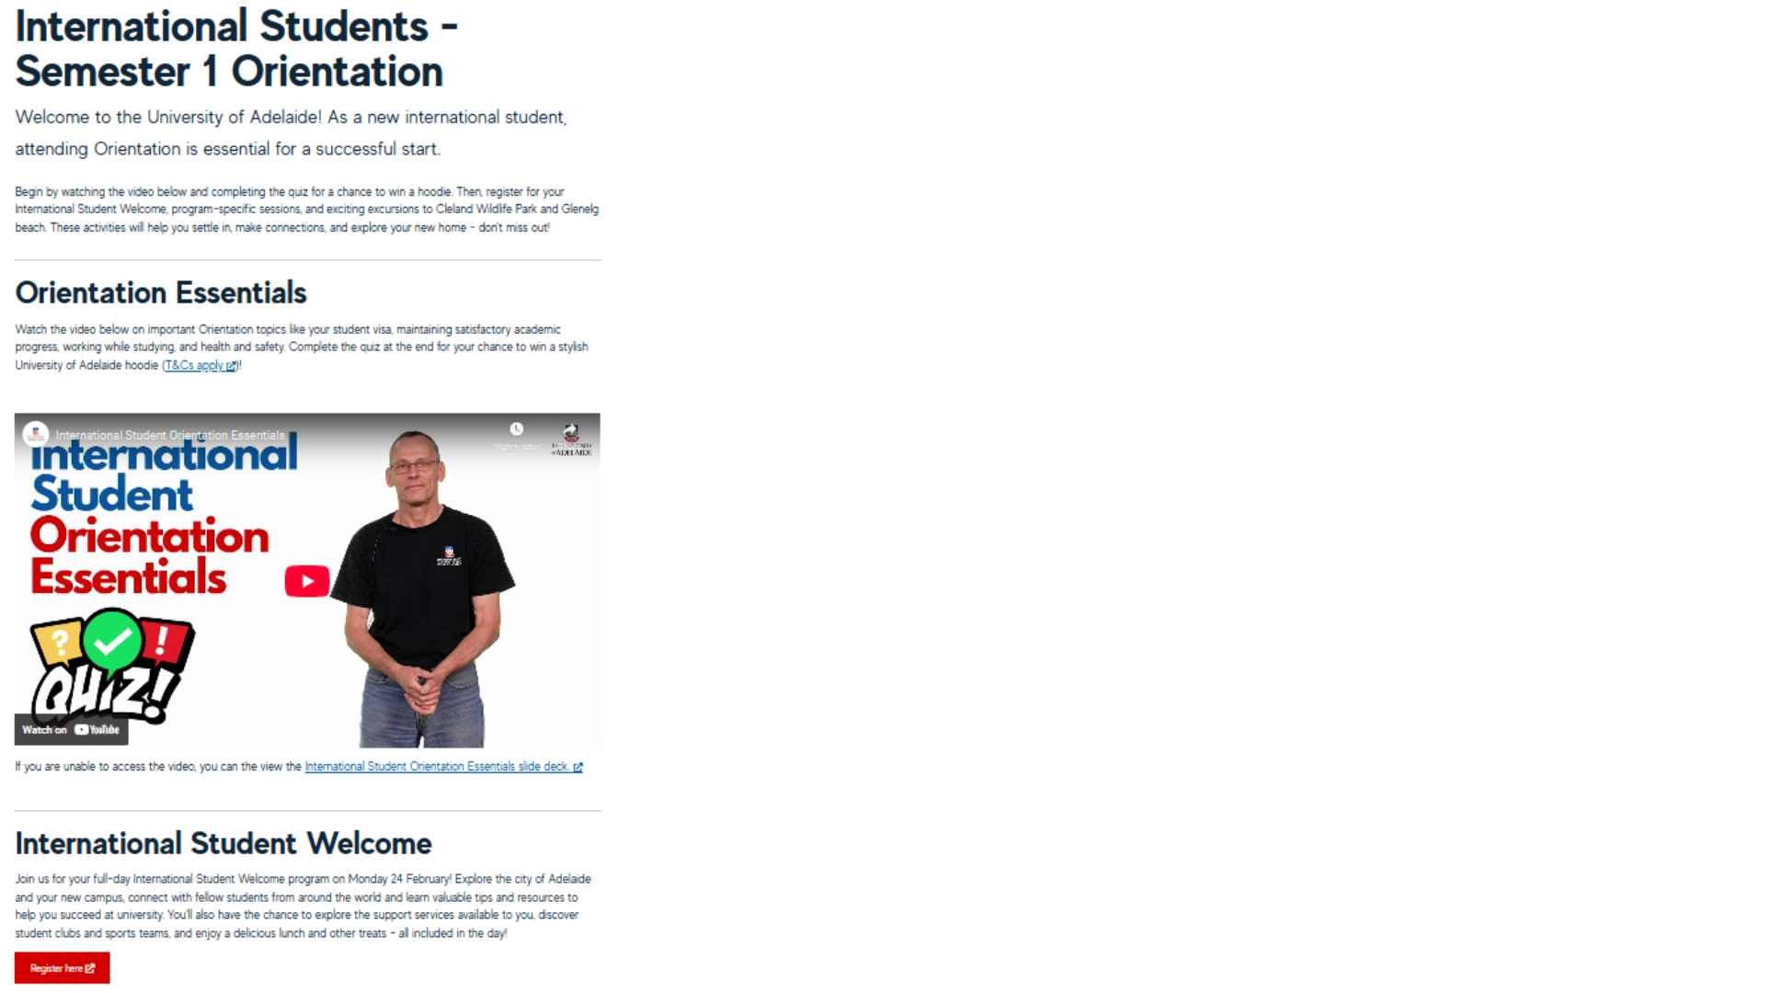
Figure 1
The International Student Welcome Web Page

Key topics—including student visa conditions, academic progress, work rights, and health and safety—were presented through questions that students attempted to answer. The ISA then provided brief yet informative explanations for each topic. At the conclusion of the video, student viewers could scan a QR code to access a self-paced online quiz covering the key information. To encourage engagement, students achieving a certain score were eligible to enter a lucky dip for a University of Adelaide branded sweater.
The video garnered 500 unique views in the three weeks before the on-campus welcome, and 184 commencing students scanned the QR code and completed the quiz. In line with flipped learning strategies—including spaced repetition and active recall—and acknowledging that not all students would engage with the digital content, the ISS team incorporated essential information from the quiz into the in-person welcome sessions. This was achieved through revamped campus tours and a purpose-built activity named the “Mystery Bag Challenge”.

Outdoor orientation program principles: An interactive experience
The in-person ISW sessions were restructured from a traditional seated presentation format into an interactive base camp experience at the University of Adelaide’s historic Bonython Hall, its primary graduation ceremonies venue. In previous years, students attended a lecture-style event with extended presentations. This time, the venue was transformed into a vibrant and dynamic hub designed to facilitate peer-to-peer engagement. To create an immersive and welcoming environment, Bonython Hall was decorated with a red carpet, fake turf, artificial plants, life-sized cutouts of Australian animals, and a large projector screen displaying scenic videos of South Australia (see Figure 2). Background music further contributed to the atmosphere, reinforcing a sense of place and excitement.
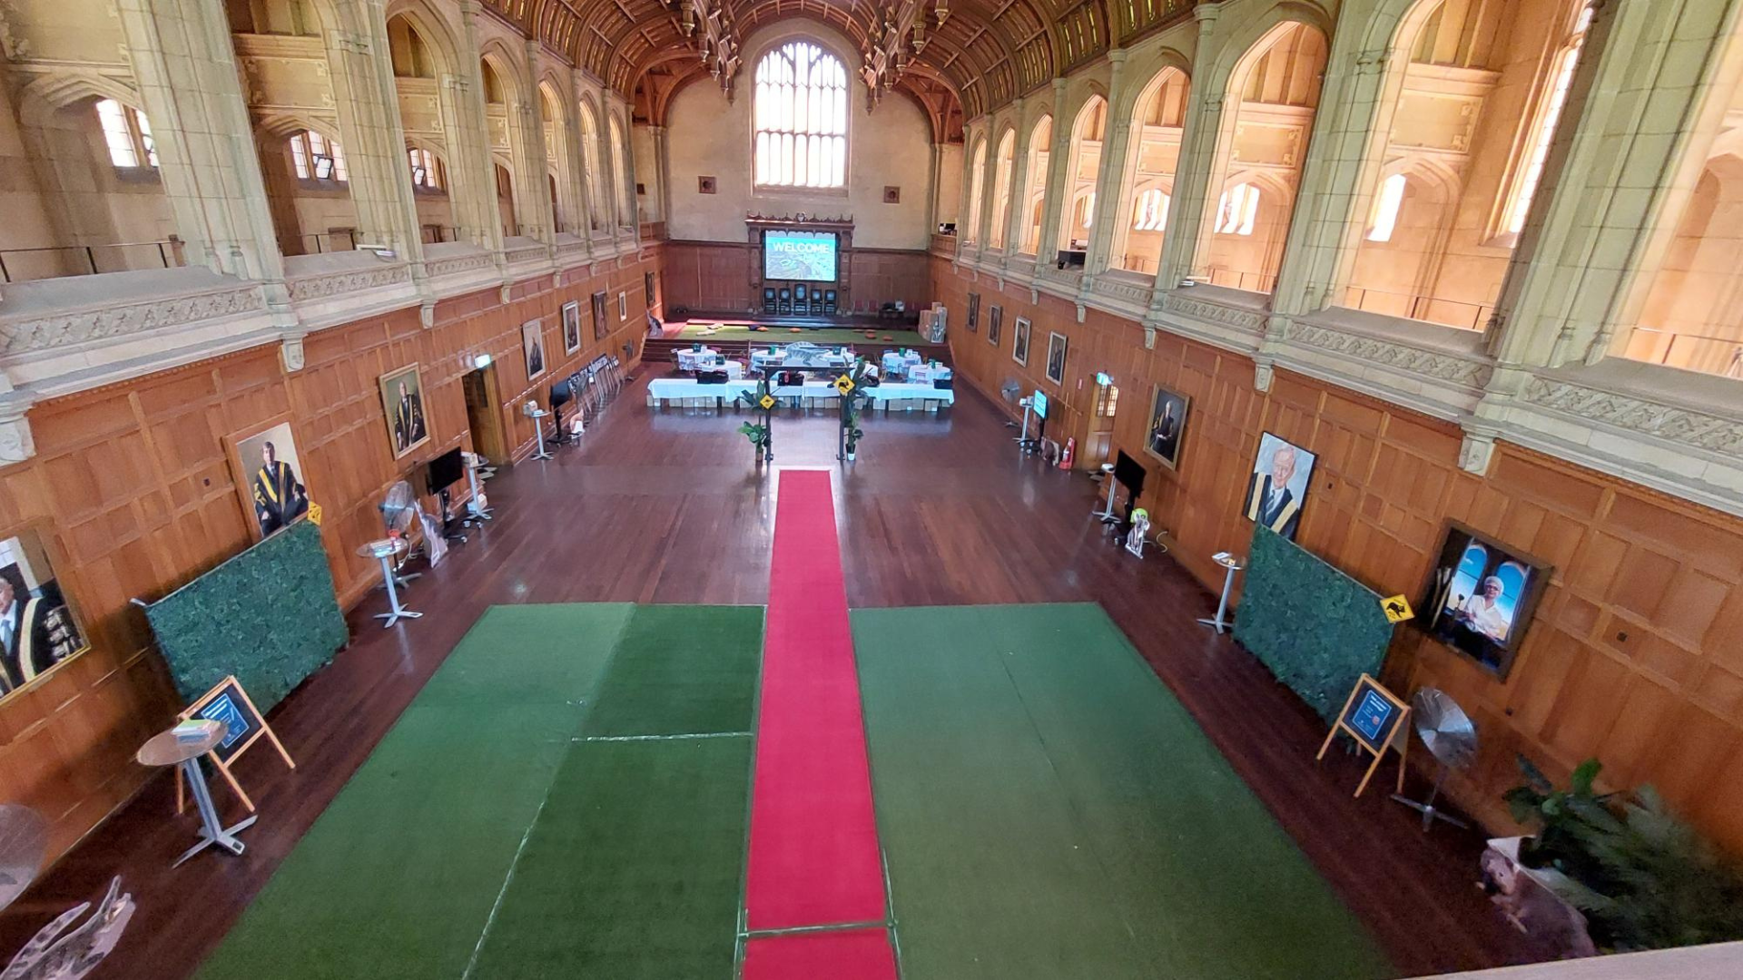
Figure 2
The International Student Welcome Base Camp on the Friday Before International Student Welcome Day

Upon arrival, students received a warm red carpet welcome. Instead of taking their seat to passively receive information, they were led by International Peer Mentors (IPMs) on discovery tours across key locations on campus and, in a break with orientation tradition, within Adelaide’s central business district. Each tour group consisted of 10 to 30 students, with two current international student volunteers carrying a shared voice amplifier. The tours began with an icebreaker activity where students took photos in different poses, fostering early engagement and camaraderie (see Figure 3). They then made their way through various campus and nearby city locations where elements of Australian culture and transition to life in Adelaide and at university were covered. Tours concluded back at the Bonython Hall base camp, where students moved through four final interactive stations. At each station, they revisited a key topic from the pre-arrival YouTube video by watching a two-minute recap and answering a quick quiz question to receive a Tim Tam, a traditional Australian cookie. ISAs were positioned next to the screens, engaging students in conversation and answering any quick questions (see Figure 4).
Figure 3
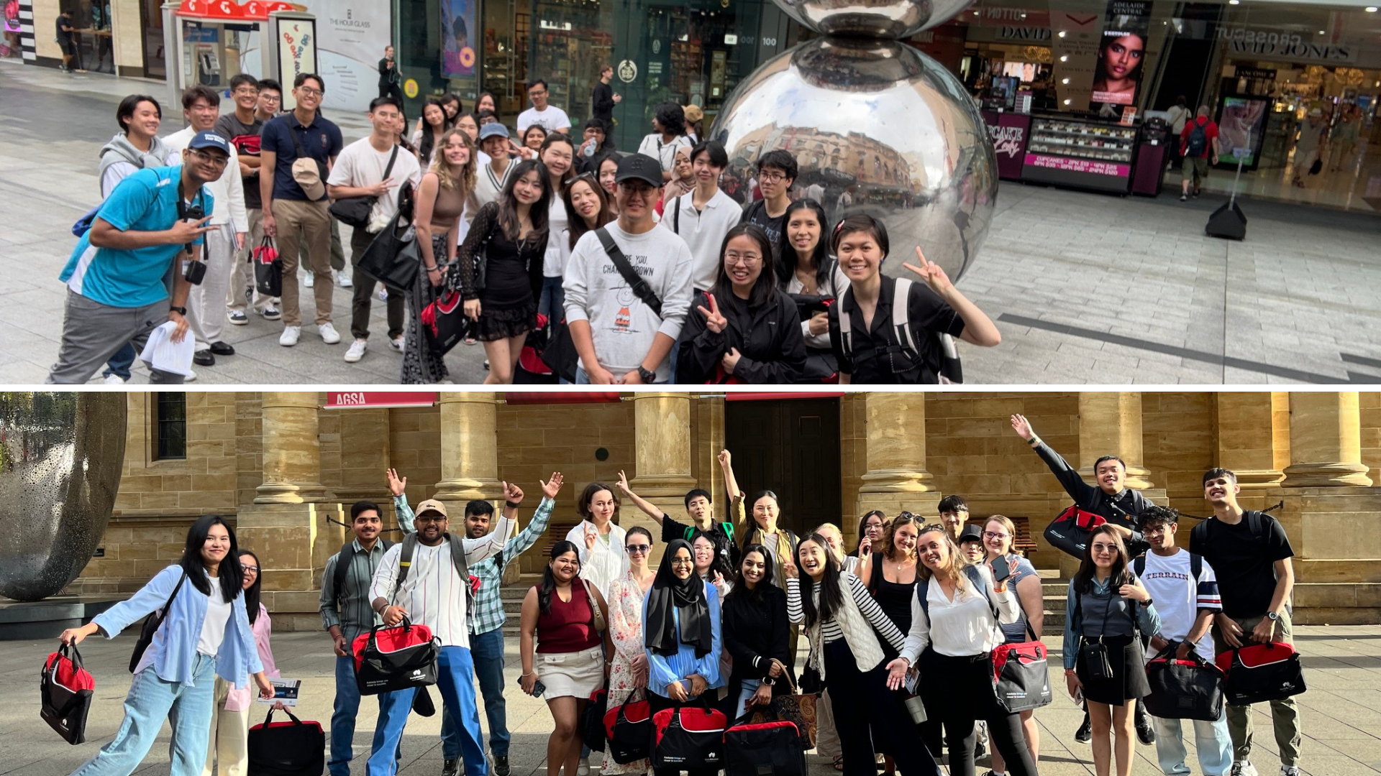
Commencing International Students Taking Part in a Campus and City Tour

After the tour, students were invited to provide some brief feedback and then to take part in three different activities: the “Aussie Lingo Wall”, the “Welcome Wall”, and the Mystery Bag Challenge (see Figure 5 and Figure 6).

Figure 4
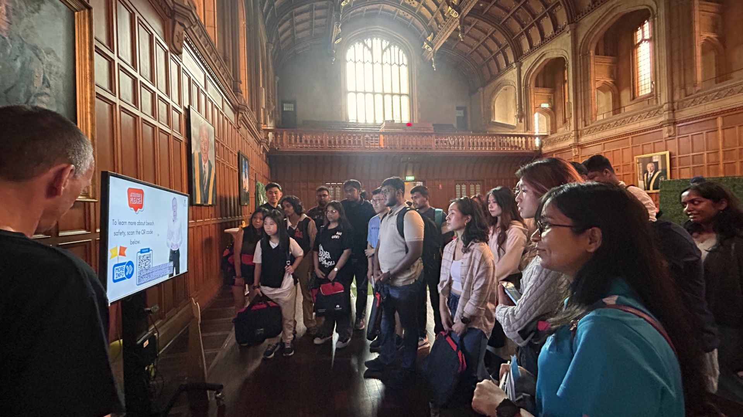
Commencing International Students at an Interactive Station Inside Bonython Hall, With the ISA Standing on the Left in the Foreground

Figure 5
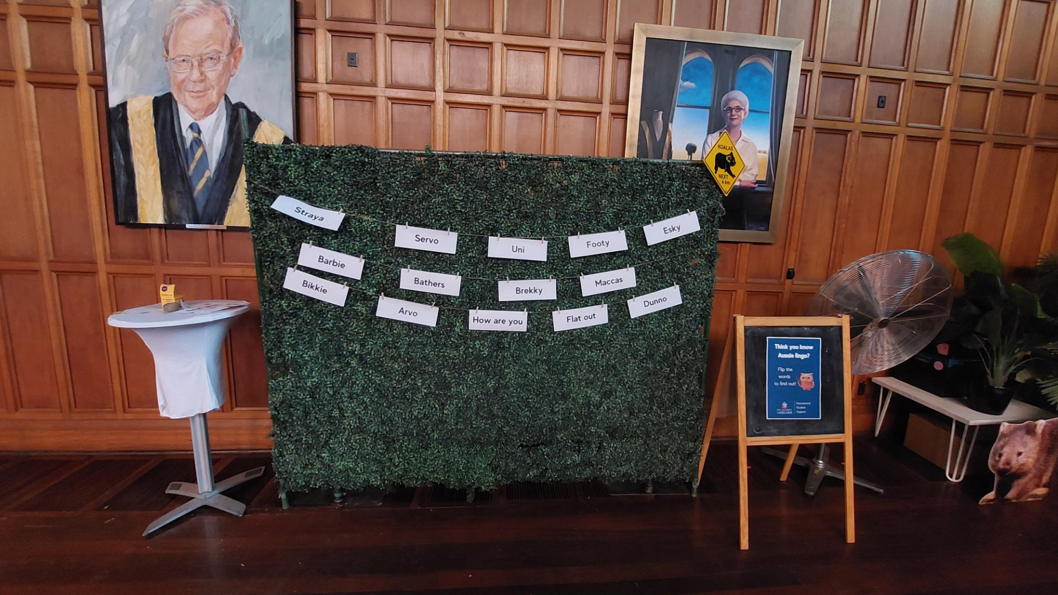
The Aussie Lingo Wall

Figure 6
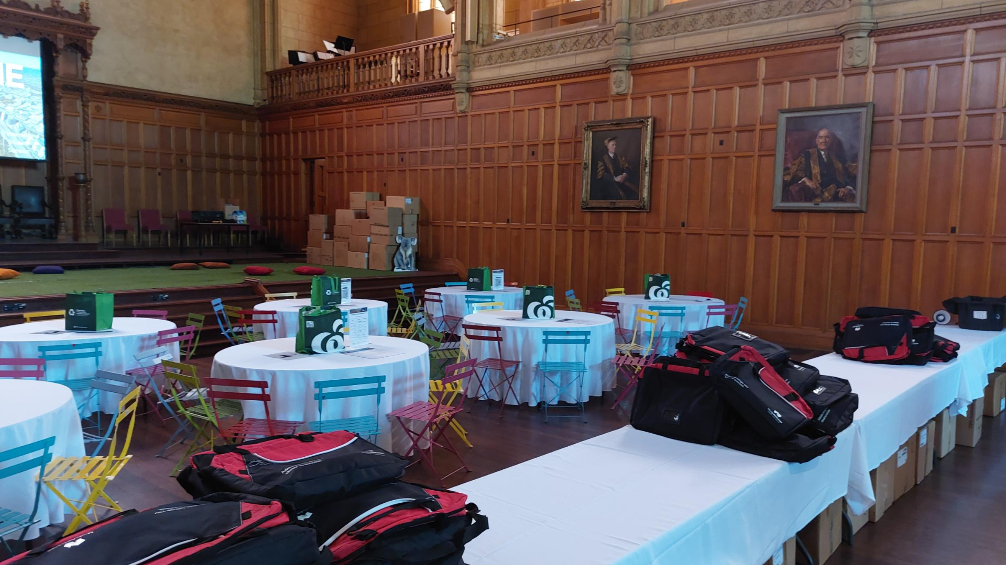
The Mystery Bag Challenge Area Inside Bonython Hall

At the Aussie Lingo Wall, students could test their knowledge of Australian slang and learn aspects of Australian culture from staff in attendance. The Welcome Wall invited students to leave messages of encouragement for their peers or share what excited them the most about their new academic journey in Australia. Finally, the Mystery Bag Challenge enabled students to learn or refresh their knowledge of key topics covered during the campus and city tour. During this group game, facilitated by an ISS staff member, they took turns taking out and solving clues from a “mystery bag”. In addition to flipped learning elements, all these activities leveraged the principles of OOPs by immersing students in structured, real-world experiences that encouraged peer connections and active participation.

Brand experience: Crafting a sense of belonging and identity
The redesigned ISW experience, across both online and on-campus formats, was carefully crafted to engage students across sensory, emotional, intellectual, and behavioural dimensions, aligning with the principles of brand experience. The base camp setting in Bonython Hall created an atmosphere of excitement and exploration, including a full red carpet welcome, signalling to students that they were embarking on an important and transformative journey. University of Adelaide branding was incorporated through banners, signage, and the welcome desk, reinforcing institutional identity from the outset (see Figure 7).
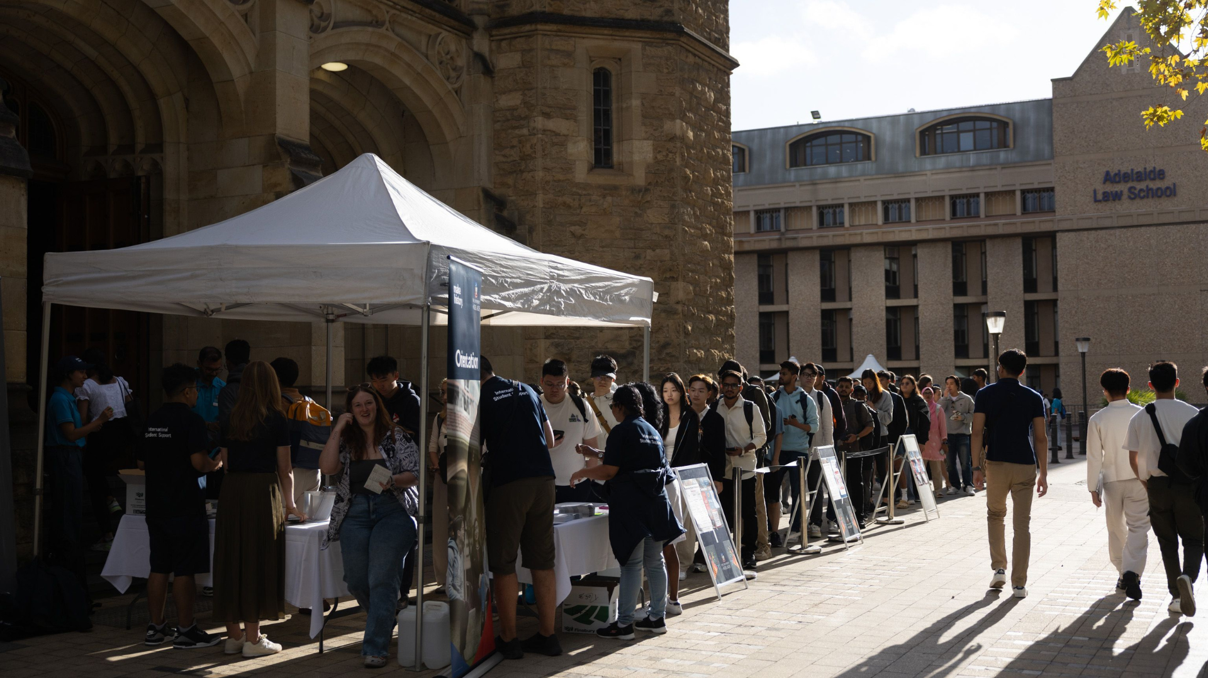
Figure 7
Commencing International Students Queuing at the Registration Desk Outside Bonython Hall

The IPM-led campus and city tours encouraged interaction and collaboration through structured activities, including planned icebreakers, pop quizzes, and opportunities to connect via the Aussie Lingo Wall, the Welcome Wall, and the Mystery Bag Challenge. In the afternoon, all commencing international students were invited to a relaxed social gathering featuring fun games and a pizza break (see Figure 8). This informal environment allowed students to mingle, revisit the interactive activities, and unwind, fostering emotional and social connections in a low-pressure setting. By integrating play and shared experiences, the event cultivated a positive emotional association with the university, fostering a sense of belonging.

Figure 8
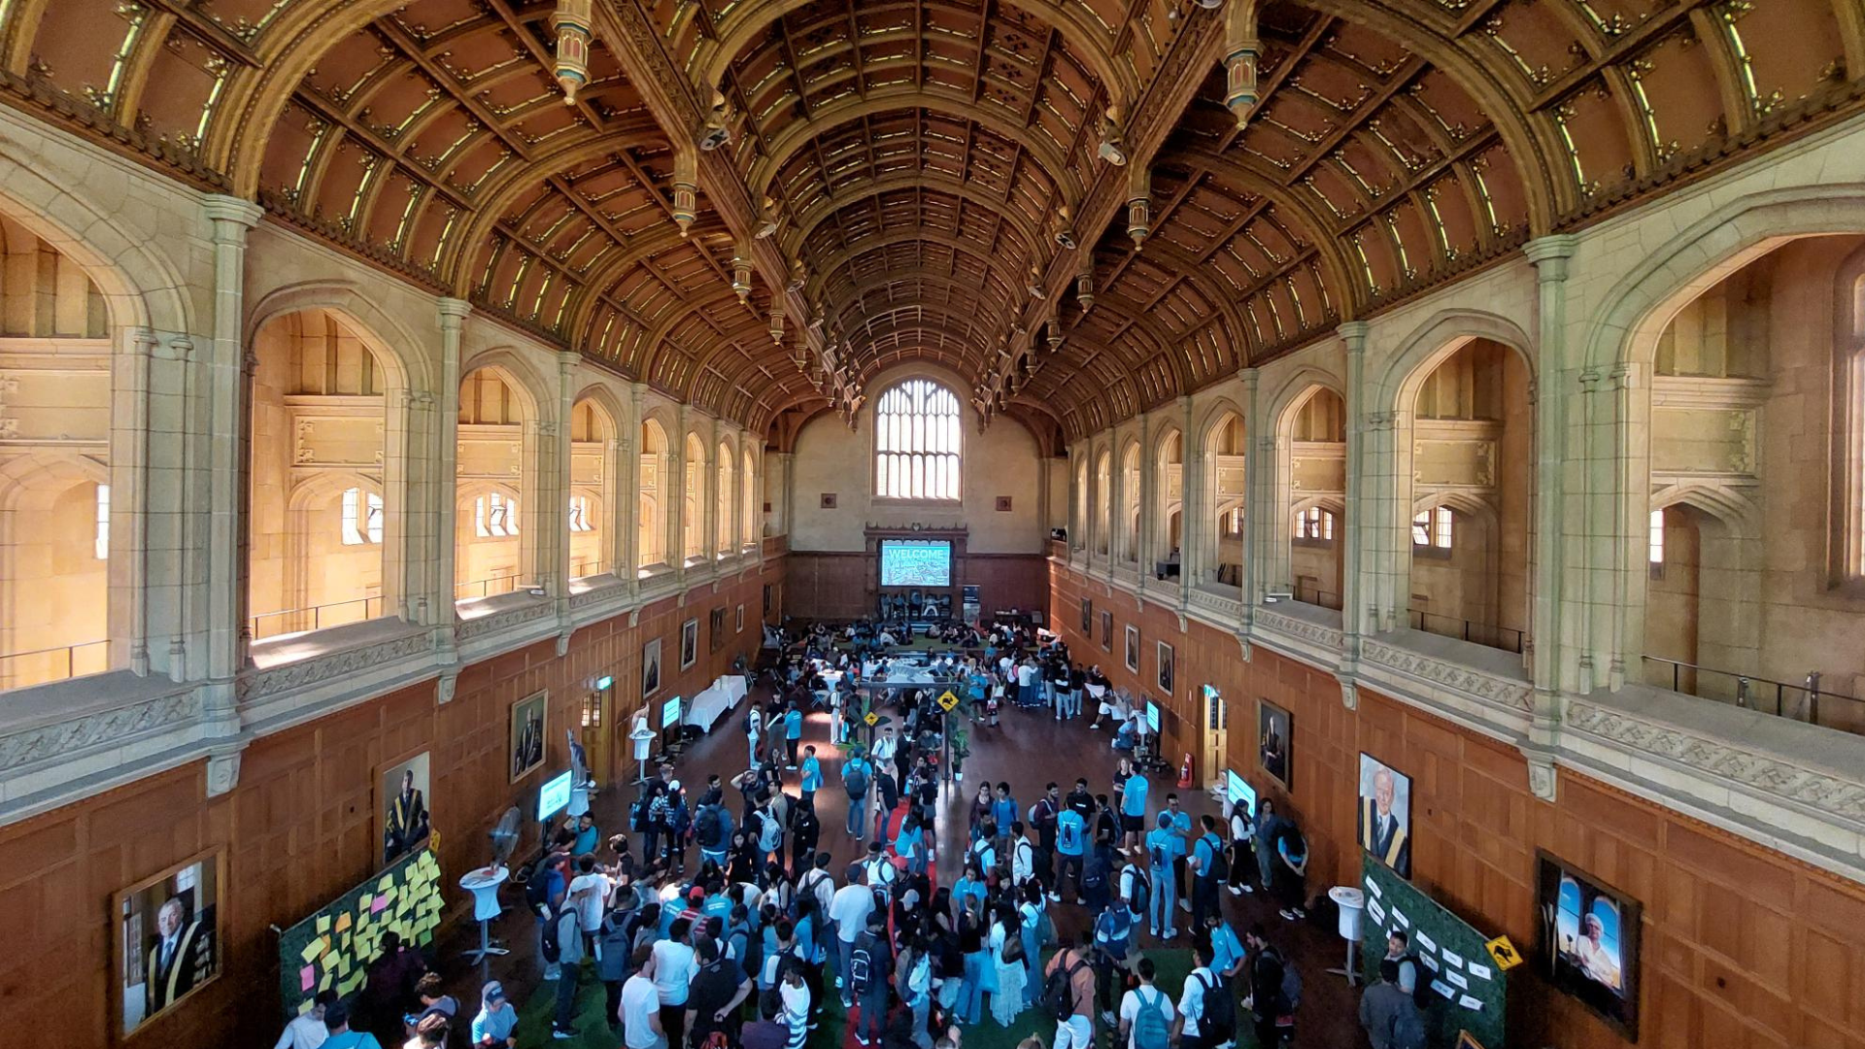
International Student Welcome Base Camp During the Food, Fun and Games Session in the Afternoon

Additionally, students received welcome packs containing University of Adelaide brochures on ISS services and scam awareness. These resources not only provided practical guidance but also highlighted the university’s commitment to student well-being and success. By structuring the ISW through this cohesive blend of digital preparation and in-person immersion, the ISS team ensured that students associated their first major university experience with a supportive environment, meaningful peer interactions, and a strong sense of institutional identity.

After the International Student Welcome: Student and staff voices
Due to the novelty of the experience and the desire to document lessons learned for the future Adelaide University’s orientation planning, students were asked to complete a short feedback form at the end of each campus and city tour. Following the event, the ISS team also convened to share personal feedback on the event’s execution and impact.
The post-event student feedback survey, granted retrospective ethical exemption by the Chairman of the Human Research Ethics Committee at the University of Adelaide on 13 June 2025, was overwhelmingly positive. Of the 325 respondents, 91% rated the tour as either “Excellent” (68.5%) or “Very Good” (22.5%), with 7% and 2% of survey takers rating it “Good” and “Fair” respectively. Additionally, 95% of students felt that the welcoming experience was very well-organised. These high satisfaction rates highlight the program's success in providing a structured and engaging introduction to both the campus and the city. Participants particularly appreciated the city orientation component, which was praised for introducing key locations in Adelaide’s central business district and for sharing relevant and useful information.
A notable number of feedback responses reflected moments of enjoyment, social connection, and early signs of belonging. References to shared experiences such as campus and city tours, interactive activities, and peer-led guidance were frequently accompanied by emotionally positive language. Students responding anonymously via the feedback form described the experience as “so welcoming and interactive with the quizzes”, noted enjoying “meeting new friends”, and appreciated “the enthusiasm of the guides” and “the friendly demeanour of the volunteers”. Others highlighted the sense of comfort and togetherness offered by the experience, stating that they appreciated the fact that “we can talk to each other, make new friends”, “hangout with new friends”, and that “the community is great”.
It is important to note, however, that the reflection prompts used to collect this feedback were not specifically designed to elicit responses about emotional engagement or belonging. Questions such as “What did you like the most?” and “What was the most valuable/important thing you learned?” were open-ended and primarily geared toward content recall to assess the effectiveness of the flipped learning and OOP principles. Despite this, affective and relational themes emerged organically:

The tour really helped me meeting new people and getting to learn a lot of things about the city. (Anonymous student)

The most valuable thing I learned during the orientation tour at the University of Adelaide was the range of student services and support available. From academic assistance, such as tutoring and library resources, to mental health support, career guidance, and student wellbeing programs, it was reassuring to know that the university provides so many resources to help students succeed. (Anonymous student)

[I liked] being together and interacting with fellow international students. The welcoming atmosphere, enthusiasm, and helping attitude of everyone was great. (Anonymous student)

These comments suggest that beyond the dissemination of critical information, the event also contributed to shaping positive affective experiences and fostering an emerging sense of community, with “friendly” and “welcoming” being the most frequent descriptors used by students.
Notwithstanding the strong positive response, several areas for improvement were identified. Some students felt that the tour groups were too large, which impacted accessibility and the pacing of the experience. Technical issues—particularly with the hand-held microphones and sound quality—occasionally hindered the IPM tour guides’ ability to communicate effectively. Nonetheless, the tour achieved its primary objectives. Students reported a significantly improved ability to navigate the campus and identify essential buildings and services. Many also gained a clearer understanding of Adelaide’s layout and important points of interest, while appreciating the insights into student life, available support services, and Australian culture.
Staff feedback echoed student appreciation of the tours’ success and included shared reflections on the program’s design and execution. Several staff members commented on the impact of the new format, with one describing the base camp-style welcome as “really brilliant”. Staff agreed that this approach transformed the traditional passive model of “learning from listening” by adopting a more experiential, hands-on method. It was especially rewarding for many to observe students chatting and introducing themselves while waiting for their campus and city tours, and to hear them enthusiastically answering the quiz questions in their groups at the interactive stations. Overall, staff praised the format as an innovative and engaging way to deliver essential ESOS compliance information.
At the same time, staff identified opportunities for refinement. Several suggested that an official welcome from university leadership at the beginning of the day would have provided clearer guidance and set the tone more effectively. The scheduling of morning and afternoon sessions was also noted as potentially confusing for students; a two-day model with a clearly structured program was proposed as a better alternative. While the four interactive stations at the end of the campus and city tours were seen as a creative addition, not all students in larger groups could see the screens clearly. In contrast, the traditional seated Mentimeter presentations projected on multiple screens around the hall were considered more effective for delivering key compliance information.
Building on student feedback, ISS staff proposed a revised structure for the ISW to be held in Bonython Hall, arranged in a festive atmosphere with circular tables rather than rows of chairs. Students would be warmly welcomed and guided to tables for icebreaker activities with peers. An official welcome and concise presentations via Mentimeter would provide the overall context and essential information before transitioning to the well-received campus and city tours. These tours would conclude at the student and sports club fair, potentially followed by additional social activities later in the day. By incorporating these collaborative insights, future iterations of the ISW at the University of Adelaide can continue to evolve as a student-centred, engaging, and informative introduction to university life.

Conclusion
In The Power of Moments (2017), Chip and Dan Heath argue that the most memorable and meaningful experiences are shaped by moments of elevation, insight, pride, and connection. The ISS team did not set out with this reference in mind. However, it is evident in hindsight that the Semester 1, 2025 ISW, with its combination of shared discovery, practical learning, and social interaction, helped create a milestone moment for many international students as they embarked on their university journey.
In their anonymous feedback, students described experiences of connection, often highlighting the friendships formed, warm peer mentor support, and the welcoming university atmosphere. Phrases such as “[I liked] meeting/making new friends”, “[I liked the] engagement with the peer mentors”, and “[I liked] hanging out with other friends around the university campus” illustrated how the event facilitated social bonds. Students also articulated insight, noting the value of learning “how to survive here as an international student” and discovering essential support services and safety tips. Other responses reflected elevation—brief but memorable moments of fun such as the quizzes, group photos, games, and goodie bags that made the experience feel celebratory. A smaller number of students expressed pride, referencing their appreciation for the “historical legacy of the University of Adelaide”, or describing the campus as “beautiful” and “amazing”. Taken together, these reflections suggest an experience that was, if not a defining moment in their journey, certainly a formative and memorable one.
These outcomes are the result of a deliberately designed experience. By blending flipped learning strategies, experiential activities, and thoughtful design of the welcome environment, the ISS team was able to offer more than just an orientation. It created a community-driven experience that supported both the informational aspects of transitioning to university life and emotional connection. Rather than passively receiving information, students actively participated in their own welcome, building familiarity with their surroundings and forming early bonds with peers. This approach provided a more holistic and student-centred alternative to traditional delivery models.
Of course, innovation inevitably comes with challenges and several elements stand to benefit from refinement in future iterations. Further research is also recommended to investigate knowledge retention by international students via experiential, hands-on programs compared to traditional formats.
Nonetheless, piloting a new approach yielded valuable insights into how orientation programs can be reimagined to more effectively support international students. The core principles of flipped learning, active participation, community building, and experiential learning appear transferable to diverse settings.
Orientation is a foundational experience, one that has the potential to shape students’ confidence, sense of belonging, and connection to the university. While the ISW model at the University of Adelaide continues to evolve, particularly as the institution undergoes its own transformation, we hope that sharing our experience offers colleagues across the sector ideas and encouragement. Whether through small innovations or more comprehensive redesigns, there is space to create welcome programs that are not only effective, but also memorable. Moments matter, and in international education, they can make all the difference.

Declaration of AI and AI-assisted technologies in the writing process
The ISS team at the University of Adelaide is committed to enhancing the experience of international students through best practices and innovative solutions. In line with this commitment and acknowledging the growing adoption of generative artificial intelligence (AI) in the higher education sector, the author used Claude 3.7 Sonnet to suggest improvements to the structure and flow of this paper after independently developing its original ideas and primary content. While the AI tool provided useful suggestions for content organisation, it showed limitations in refining stylistic elements and maintaining consistent grammar. Following the application of this tool, the author critically reviewed and edited the content as necessary without further generative AI assistance. The author assumes full responsibility for the final content, arguments, and conclusions presented in this paper. The purpose of this declaration is to ensure methodological transparency and to contribute to the ongoing discussion about the role of AI tools in academic research and writing.

Acknowledgements
I am grateful to the International Student Support team at the University of Adelaide for their contribution and support in delivering the International Student Welcome experience described in this paper. I extend particular thanks to the International Peer Mentors, Class of 2025, whose enthusiasm and dedication helped make the event a memorable and welcoming experience for commencing students in Semester 1, 2025. I also would like to thank the two anonymous journal reviewers and the JANZSSA editorial team for their constructive feedback and copy editing support.

References
Abeysekera, L., & Dawson, P. (2015). Motivation and cognitive load in the flipped classroom: Definition, rationale and a call for research. Higher Education Research & Development, 34(1), 1–14. https://doi.org/10.1080/07294360.2014.934336
Altschwager, T., Dolan, R., & Conduit, J. (2018). Social brand engagement: How orientation events engage students with the university. Australasian Marketing Journal, 26(2), 83–91. https://doi.org/10.1016/j.ausmj.2018.04.004
Andre, E., Williams, N., Schwartz, F., & Bullard, C. (2017). Benefits of campus outdoor recreation programs: A review of the literature. Journal of Outdoor Recreation, Education, and Leadership, 9, 15–25. https://doi.org/10.18666/JOREL-2017-V9-I1-7491
Bell, B., Holmes, M., & Williams, B. (2010). A census of outdoor orientation programs at four-year colleges in the United States. Journal of Experiential Education, 33(1), 1–18. https://www.outdoored.com/wp-content/uploads/OOPS_Census_Bell_Holmes_Williams-1.pdf
Bergmann, J., & Sams, A. (2012). Flip your classroom: Reach every student in every class every day. International Society for Technology in Education.
Brakus, J. J., Schmitt, B. H., & Zarantonello, L. (2009). Brand experience: What is it? How is it measured? Does it affect loyalty? Journal of Marketing, 73(3), 52–68. https://doi.org/10.1509/jmkg.73.3.052
Department of Education. (2018). National Code of Practice for Providers of Education and Training to Overseas Students 2018. https://www.education.gov.au/esos-framework/national-code-practice-providers-education-and-training-overseas-students-2018
Edward, N. S. (2003). First impressions last: An innovative approach to induction. Active Learning in Higher Education, 4(3), 226–242. https://doi.org/10.1177/14697874030043003
Glass, C. R., Kociolek, E., Wongtrirat, R., Lynch, R. J., & Cong, S. (2015). Uneven experiences: The impact of student-faculty interactions on international students’ sense of belonging. Journal of International Students, 5(4), 353–367. https://doi.org/10.32674/jis.v5i4.400
Glass, C. R., & Westmont, C. M. (2014). Comparative effects of belongingness on the academic success and cross-cultural interactions of domestic and international students. International Journal of Intercultural Relations, 38, 106–119. https://doi.org/10.1016/j.ijintrel.2013.04.004
Heath, C., & Heath, D. (2017). The power of moments: Why certain experiences have extraordinary impact. Simon & Schuster.
Hendrickson, B., Rosen, D., & Aune, R. K. (2011). An analysis of friendship networks, social connectedness, homesickness, and satisfaction levels of international students. International Journal of Intercultural Relations, 35(3), 281–295. https://doi.org/10.1016/j.ijintrel.2010.08.001
Kift, S. (2009). Articulating a transition pedagogy to scaffold and to enhance the first-year student learning experience in Australian higher education: Final report for ALTC Senior Fellowship Program. Australian Learning and Teaching Council. https://transitionpedagogy.com.au/wp-content/uploads/2014/03/Kift-Sally-ALTC-Senior-Fellowship-Report-Sep-092.pdf
Mayhew, M., Vanderlinden, K., & Kim, E. (2010). A multi-level assessment of the impact of orientation programs on student learning. Research in Higher Education, 51, 320–345. https://doi.org/10.1007/s11162-009-9159-2
McPhail, R., French, B., Wilson, K. (2015). Valuing orientation efficacy: Rethinking undergraduate business student’s first impressions. Journal of International Education in Business, 8(2), 109–124. https://doi.org/10.1108/JIEB-04-2015-0012
Moodie, G. (2016, March 23). Which students are most likely to drop out of university? The Conversation. http://theconversation.com/which- students- are- most- likely- to-drop-out-of-university-56276
O'Flaherty, J., & Phillips, C. (2015). The use of flipped classrooms in higher education: A scoping review. The Internet and Higher Education, 25, 85–95. https://doi.org/10.1016/j.iheduc.2015.02.002
Ribbe, R., Cyrus, R., & Langan, E. (2016). Exploring the impact of an outdoor orientation program on adaptation to college. Journal of Experiential Education, 39(4), 355–369. https://doi.org/10.1177/1053825916668900
Sereni, A. (2024). The crucial role of international student support experts: Creative initiatives empowering international students at the University of Adelaide. Journal of the Australian and New Zealand Student Services Association, 32(2), 183–196. https:/​/​doi.org/​10.30688/​janzssa.2024-2-09
Smyth, E., & Lodge, J. (2012). Orientation Online: Introducing commencing students to university study. A Practice Report. The International Journal of the First Year in Higher Education, 3(1). 83–90. https://doi.org/10.5204/intjfyhe.v3i1.104
Sum, V., McCaskey, S. J., & Kyeyune, C. (2010). A survey of satisfaction levels of graduate students enrolled in a nationally ranked top-10 program at a mid-western university. Research in Higher Education Journal, 7(2), 1–17. http://www.vichetsum.com/09403.pdf
Wolfe, B. D., & Kay, G. (2011). Perceived impact of an outdoor orientation program for first-year university students. Journal of Experiential Education, 34(1), 19–34. https://doi.org/10.1177/105382591103400103
Zimmer, S. (2021). Student orientation in higher education institutions. EBSCO. https://www.ebsco.com/research-starters/education/student-orientation-higher-education-institutions

The author may be contacted via:
Alessandro Sereni — alessandro.sereni@adelaide.edu.au

Please cite this paper as:
Sereni, A. (2025). Beyond information sessions: Transforming the International Student Welcome experience. Journal of the Australian and New Zealand Student Services Association, 33(2), 190–204. https://doi.org/10.30688/janzssa.2025-2-03



This work is licensed under the Creative Commons Attribution 4.0 International License. To view a copy of this license, visit http://creativecommons.org/licenses/by/4.0/ or send a letter to Creative Commons, PO Box 1866, Mountain View, CA 94042, USA.

A typical welcome event includes an official greeting from university leaders, a Welcome to Country ceremony led by a First Nations representative, and information about international students' rights and responsibilities. Other presentations cover Australian culture and campus services. International students usually join campus tours and take part in various on-campus activities such as student and sports club fairs.
These figures are drawn from two sources: the university’s internal Student Lifecycle Reporting system and Humanitix attendee reports. While the ISS team aims to welcome as many international students in person as possible, those unable to attend the ISW for their intake access the same essential information through a dedicated online module. This module is part of the ISS non-teaching course on MyUni, the university’s Learning Management System, in which all current international students are enrolled. To learn more about the latter, refer to: Sereni, A. (2024). The crucial role of international student support experts: Creative initiatives empowering international students at the University of Adelaide. Journal of the Australian and New Zealand Student Services Association, 32(2), 183–196. https://doi.org/10.30688/janzssa.2024-2-09.
“IPMs are international and domestic students who collaborate with the ISS team to deliver quality transition support to new international students, while also developing leadership skills and forming long-term friendships. Through their involvement, IPMs also play a key role in enhancing the University’s celebration of cultural diversity by co-creating inclusive and engaging cultural exchange and festival experiences throughout the academic year.” (Sereni, 2024, p. 185)

